THE REEL WALA

Pages - in orange

SERVICES

Private Events
- Weddings & Receptions
- Mehendi, Sangeet, Haldi, Make-Up Shoots
- Birthdays & Anniversaries
- NEW CAR DELIVERY
- Baby Showers, Naming Ceremonies & Annaprashan
- Birthday Parties & Graduation Days
- Proposal & Pre-Wedding Shoots
- PET SHOOTS
- Housewarming
- Family Gatherings & Home Tours

Corporate EVENTS

- Team outing, Team lunch / Dinner
- Corporate Parties
- Annual & Quarterly Meetups
- Office Celebrations
- Company Anniversaries
- Product Launches
- Sports & Corporate Tournaments
- Store / Product launches

Social / Cultural Events

- Cultural Fests & Carnivals
- Festivals : Diwali, Holi, Eid, Christmas, Gudi Padwa & more
- Community / society events
- Music Festivals & Concerts
- Stand-Up Comedy Shows
- Fashion Shows / Food Festivals

Testimonials

PRICING
Standard package
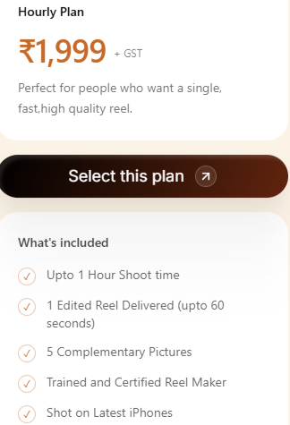
TAG LINE - Quick, focused content for when you need a high-quality reel without the wait.
4 COMPLEMENTARY COLOR GRADIANT PICTURE
Within 24 hours reel delivery

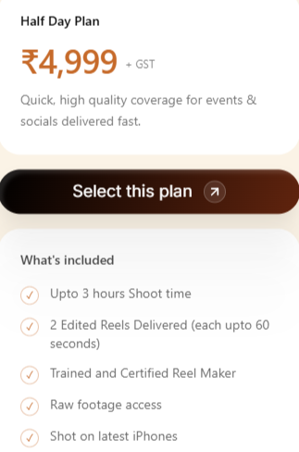
Tag line - Ideal for longer shoots, events, and creating multiple high-quality reels in one session.
Upto 4 hours shoot time
7 COMPLEMENTARY COLOR GRADIANT PICTURE
Within 24 hours reel delivery

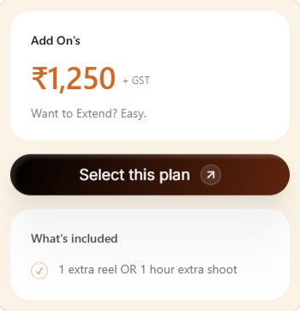
TAG LINE - Extended hour
1000rs

Premium package

Workflow
Step 1
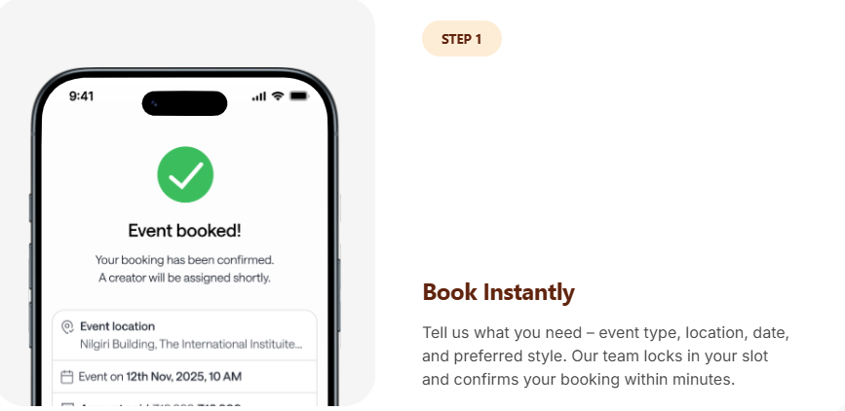
Booking - Tell us where, what & when.

Step 2

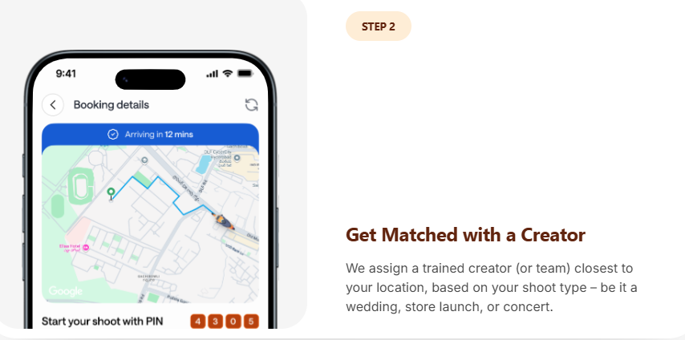
Reeler Assigned - A professional reel creator will be assigned to your event, and their details will be shared with you.

Step 3 - Same day Delivery
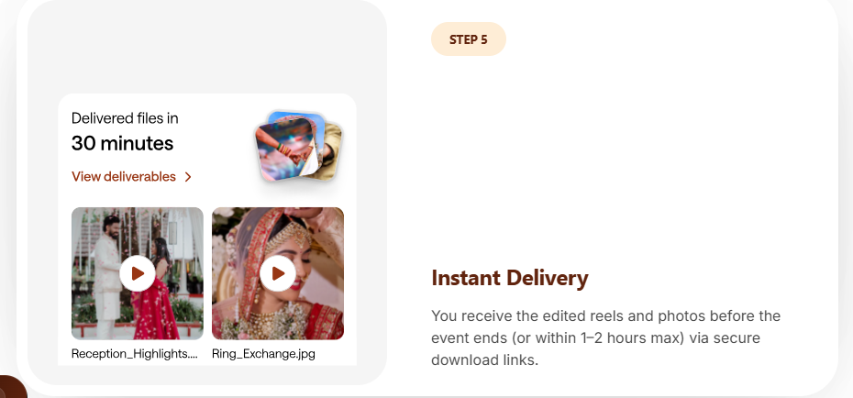
Reel and Pics will be shared within 24 hours via secure Download link

Workflow wale page pe hi LEAD GEN form, where customers can fill up their event/occosion details,
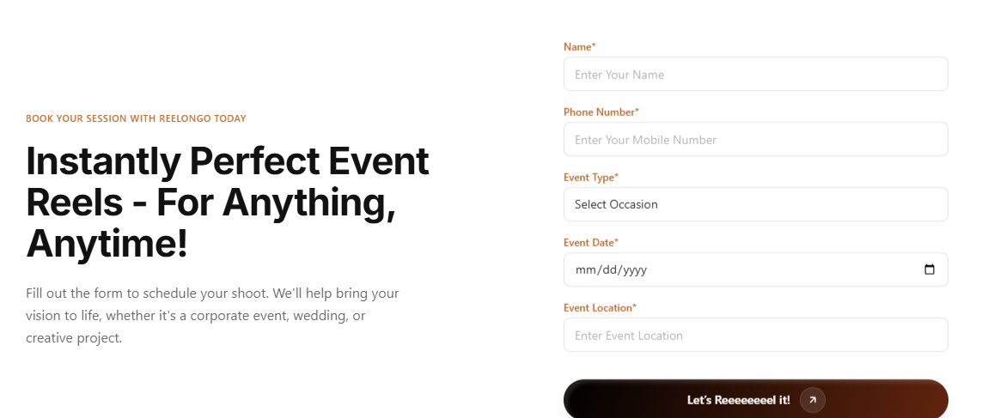
Left side text -
Book Your Shoot with TheReelWala
Your Events, Captured in Reels!
From corporate gatherings to weddings and creative events, we turn your special moments into engaging, scroll-stopping reels.
Fill out the form to book your session. Let’s create content that captures the vibe of your event and makes every moment worth sharing.

NEED THIS ALSO (Be a Creator)
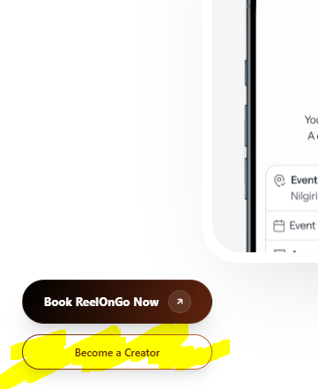
Form
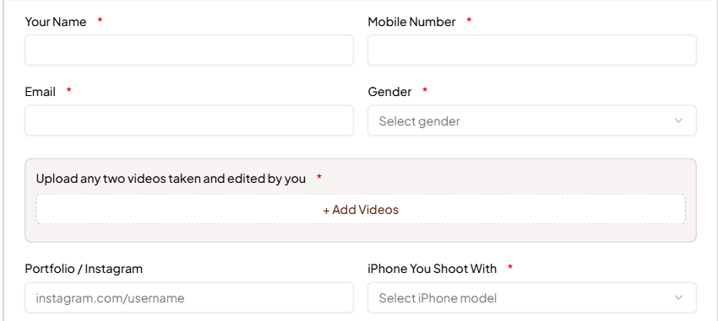
I phone wale option me drop down dena hai
I phone 15 ke upar ke sare models,
Ek isme LOCALITY - wala option bhi dene ka hai
Jisme placeholder ho - Type Your Area Like “Viman Nagar”
Upload any two videos edited by you can be kept non mandatory
Also add one section of “Upload Best 5 pics clicked by you”

This 4 steps to make CREATOR understand how the flow will work,
First they have to register, thn attend the workshop, thn receive shoots and after shoots payments

Link of page

